CMSC 204

Huffman Lab

1. Create a Huffman Tree and generate the codes for each character of the following input:

create a huffman tree

For consistency:

1. If same frequency – put in priority queue alphabetically; put space before other characters of the same frequency
2. Add subtrees to end of group with same priority
3. Lower number has higher priority (goes to front)

H=1 U=1 C=1 M=1 N=1 R=2 F=2 T=2 A=3 E=4

Now encode “create a huffman tree”

1. Based on the following Huffman tree and binary sequence, what is the text

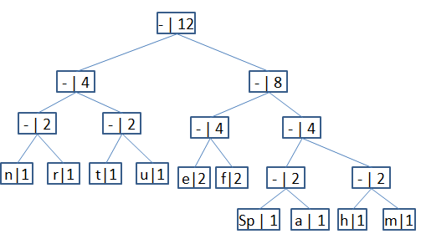

1110011101101111111010001100010001100100

Huffman Tree